# InfyDrive File Upload Steps

**Step 1**

* The team member will receive an email from InfyDrive owner, with an Upload link.
* The Upload link will be valid maximum of 7 Days.

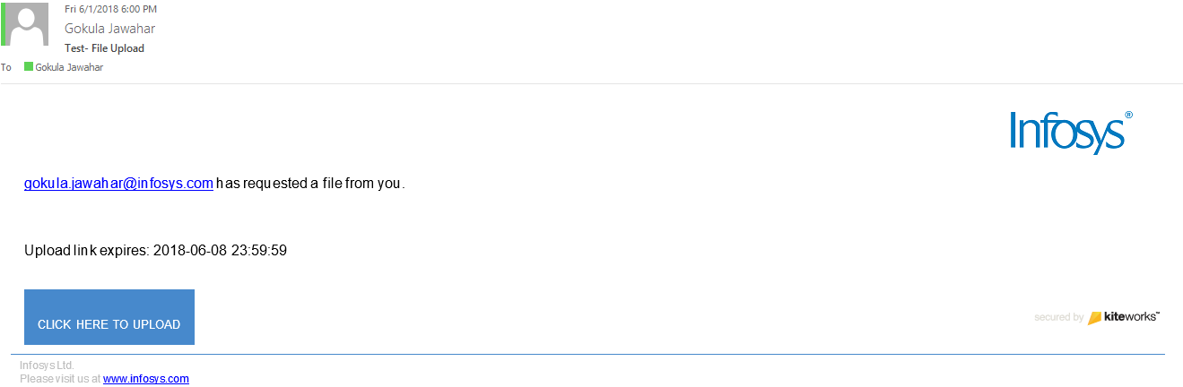

**Step 2**

* Click on Upload, you will navigate to the InfyDrive’ s landing page.
* Click Select files, browse and add files
* Once you are done, you will be able to see the list of files added.
* If any file needs to be deleted before uploading, click Delete symbol against the file name.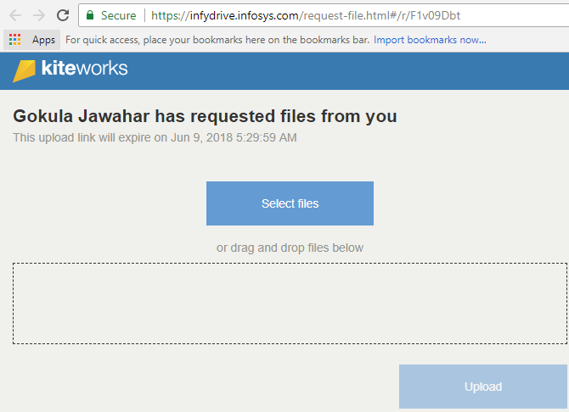 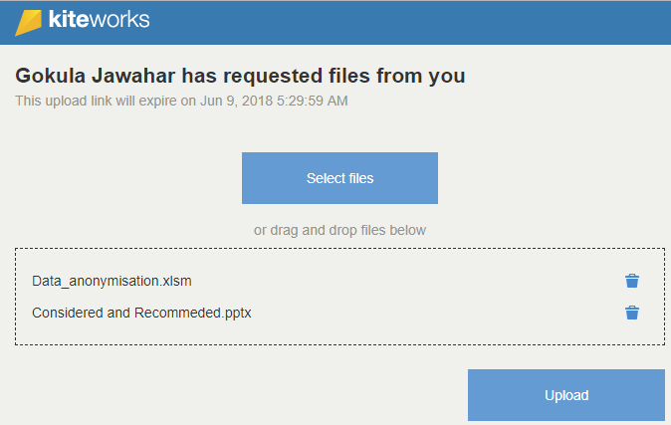

**Step 3**

* Once you are done verifying the no of file, Click upload.
* Once uploaded, the operation cannot be revoked

